# **Introduction**

HTML stands for Hypertext Markup Language, and it is the most widely used language to write Web Pages. Hypertext refers to the way in which Web pages (HTML documents) are linked Together. Thus, the link available on a webpage is called Hypertext. As its name suggests, HTML is a Markup Language which means you use HTML to simply "mark-up" a text document with tags that tell a Web browser how to structure it to display. Originally, HTML was developed with the intent of defining the structure of documents like headings, paragraphs, lists, and so forth to facilitate the sharing of scientific information between researchers. Now, HTML is being widely used to format web pages with the help of different tags available in HTML language. A CSS (cascading style sheet) file allows you to separate your web sites (X)HTML content from its style. As always you use your (X) HTML file to arrange the content, but all of the presentation (fonts, colors, background, borders, text formatting, link effects & so on...) are accomplished within a CSS, Bootstrap is the most popular front-end framework for developing websites. We see a lot of customers using Bootstrap to format invoices and reports while converting them from HTML to PDF with DocRaptor. However, there are several common issues you may run into when using Bootstrap 3 with DocRaptor.

**History**

Development

In 1980, physicist Tim Berners-Lee, a contractor at CERN, proposed and prototyped ENQUIRE, a system for CERN researchers to use and share documents. In 1989, Berners-Lee wrote a memo proposing an Internet-based hypertext system. Berners-Lee specified HTML and wrote the browser and server software in late 1990. That year, Berners-Lee and CERN data systems engineer Robert Cailliau collaborated on a joint request for funding, but the project was not formally adopted by CERN. In his personal notes from 1990 he listed "some of the many areas in which hypertext is used" and put an encyclopedia first.

The first publicly available description of HTML was a document called ["HTML Tags"](http://info.cern.ch/hypertext/WWW/MarkUp/Tags.html), first mentioned on the Internet by Tim Berners-Lee in late 1991. It describes 18 elements comprising the initial, relatively simple design of HTML. Except for the hyperlink tag, these were strongly influenced by SGMLguid, an in-house Standard Generalized Markup Language (SGML)-based documentation format at CERN. Eleven of these elements still exist in HTML 4.

HTML is a markup language that web browsers use to interpret and compose text, images, and other material into visual or audible web pages. Default characteristics for every item of HTML markup are defined in the browser, and these characteristics can be altered or enhanced by the web page designer's additional use of CSS. Many of the text elements are found in the 1988 ISO technical report TR 9537 *Techniques for using SGML*, which in turn covers the features of early text formatting languages such as that used by the RUNOFF command developed in the early 1960s for the CTSS (Compatible Time-Sharing System) operating system: these formatting commands were derived from the commands used by typesetters to manually format documents. However, the SGML concept of generalized markup is based on elements (nested annotated ranges with attributes) rather than merely print effects, with also the separation of structure and markup; HTML has been progressively moved in this direction with CSS.

Berners-Lee considered HTML to be an application of SGML. It was formally defined as such by the Internet Engineering Task Force (IETF) with the mid-1993 publication of the first proposal for an HTML specification, the "Hypertext Markup Language (HTML)" Internet Draft by Berners-Lee and Dan Connolly, which included an SGML Document type definition to define the grammar. The draft expired after six months, but was notable for its acknowledgment of the NCSA Mosaic browser's custom tag for embedding in-line images, reflecting the IETF's philosophy of basing standards on successful prototypes. Similarly, Dave Raggett's competing Internet-Draft, "HTML+ (Hypertext Markup Format)", from late 1993, suggested standardizing already-implemented features like tables and fill-out forms.

After the HTML and HTML+ drafts expired in early 1994, the IETF created an HTML Working Group, which in 1995 completed "HTML 2.0", the first HTML specification intended to be treated as a standard against which future implementations should be based.

Further development under the auspices of the IETF was stalled by competing interests. Since 1996, the HTML specifications have been maintained, with input from commercial software vendors, by the World Wide Web Consortium (W3C). However, in 2000, HTML also became an international standard (ISO/[IEC](https://en.wikipedia.org/wiki/International_Electrotechnical_Commission) 15445:2000). HTML 4.01 was published in late 1999, with further errata published through 2001. In 2004, development began on HTML5 in the Web Hypertext Application Technology Working Group (WHATWG), which became a joint deliverable with the W3C in 2008, and completed and standardized on 28 October 2014.

### **Elements**

HTML documents imply a structure of nested HTML elements. These are indicated in the document by HTML *tags*, enclosed in angle brackets thus: <**p**>.

In the simple, general case, the extent of an element is indicated by a pair of tags: a "start tag" <**p**> and "end tag" </**p**>. The text content of the element, if any, is placed between these tags.

Tags may also enclose further tag markup between the start and end, including a mixture of tags and text. This indicates further (nested) elements, as children of the parent element.

The start tag may also include *attributes* within the tag. These indicate other information, such as identifiers for sections within the document, identifiers used to bind style information to the presentation of the document, and for some tags such as the <**img**> used to embed images, the reference to the image resource in the format like this: <**img** src="example.com/example.jpg"

Some elements, such as the line break <**br**>, or <**br** /> do not permit *any* embedded content, either text or further tags. These require only a single empty tag (akin to a start tag) and do not use an end tag.

Many tags, particularly the closing end tag for the very commonly used paragraph element <**p**>, are optional. An HTML browser or other agent can infer the closure for the end of an element from the context and the structural rules defined by the HTML standard. These rules are complex and not widely understood by most HTML coders.

The general form of an HTML element is therefore: <**tag** attribute1="value1" attribute2="value2">''content''</**tag**>. Some HTML elements are defined as *empty elements* and take the form <**tag** attribute1="value1" attribute2="value2">. Empty elements may enclose no content, for instance, the <**br**> tag or the inline <**img**> tag. The name of an HTML element is the name used in the tags. Note that the end tag's name is preceded by a slash character, /, and that in empty elements the end tag is neither required nor allowed. If attributes are not mentioned, default values are used in each case.

**Download Steps**

**1. Visual Studio code and download steps**

Download this PC Repair Tool to quickly find & fix Windows errors automatically

About three years ago Microsoft released a new source code editor for Windows, Linux, and macOS. This was named **Visual Studio Code**. It is way lighter IDE than various editions of the legendary Visual Studio 2017. It can help you debug your code; it has embedded control for Git, Syntax Highlighting, IntelliSense to help you write correct code faster, snippets and code refactoring.

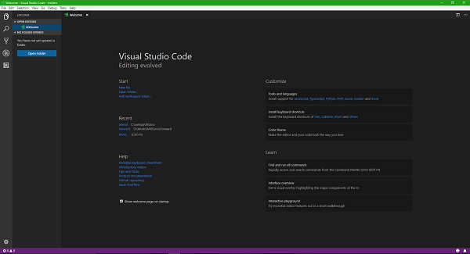

**Visual Studio Code** Visual Studio Code is a lightweight IDE from Microsoft for developers to write code in the variety of languages like Python, PHP and more. It has inbuilt support for Git as well. This article is a step by step guide about Visual Studio Code, briefing about its different channels and how to install and use it properly.It is worth mentioning that Visual Studio Code is an open source project with its repository on **Github**. Secondly, it has two versions of the product that is available for download publically. The first one is the **Stable release** that sees an update once every 15-30 days at an average. And the other one is the **Insiders release** that gets an update almost every day.The main difference between the two lies in the channel’s name. The stable release is ideal for those who are very particular about not getting any interruptions even occasionally. The other one is the Insiders channel that is the beta release actually. It contains all the latest fixes while new and many times incomplete features are implemented and hence causes bugs occasionally.

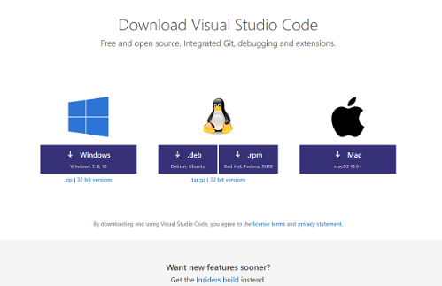

This does not mean that the Insiders version is not usable at all. The Insiders version is stable enough to not interrupt your daily tasks, but no one can call these beta versions reliable hence, it is expected that things may go wrong at some point or the other.Summing up, if you are an enthusiast who wants to try out new fixes and features earlier than others, you can download the Insiders version from the respective channel.

### **Downloading Visual Studio Code**

Downloading both the versions of Visual Studio Code is pretty simple. You just need to head to this webpage dedicated to downloads of Visual Studio Code and choose the package that matches your needs and requirements.

As we can see in the screenshot above, it supports Windows 7, Windows 8, Windows 8.1 and Windows 10 for Windows platform. We can download a **.deb** file for Debian and Ubuntu and **.rpm** file for Red Hat, Fedora and SUSE. We can also get an x32 version or 32-bit version of the software for the operating systems just mentioned and obviously the **.zip** and **.tar.gz** archives for Windows and Linux respectively. Talking about Mac OS, you can get a package for your Mac computer, but you will need to make sure if you are running version 10.9 or newer of Mac OS.

You can even get an Insider build of Visual Studio Code for Windows Platform, macOS and Linux flavors mentioned above from their dedicated page here.

### **Installing Visual Studio Code**

After you hit the download button for the package that matches your needs and configuration the most, the package will start downloading on your machine. Now, there are different ways to install this software on different operating system environments. We will concentrate on how to install it on **Windows**. I am using Windows 10 to install it, but the procedure is purely the same for every supported version of Windows Operating System.

So, after you downloaded a file named as *VSCodeSetup-version.exe*, double-click on the file to install it. It will just take about a minute to install depending on how powerful hardware you are running.

You will now get a UAC or User Account Control Prompt to which you will have to hit *Yes.*

Then you will see a window like this-

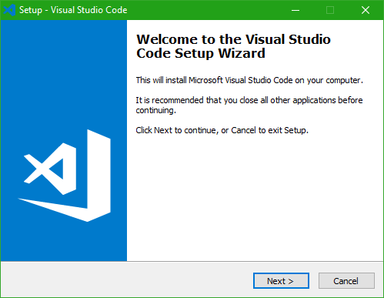

Now, hit *Next* to proceed further.

Then you will see the License Agreement page which will look like this-

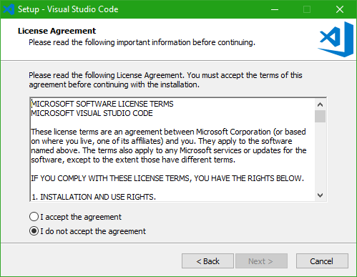

Click on the *I accept the agreement* radio button and then hit *Next.*Then you will see a page that will ask and show the default path where Visual Studio Code will be installed. By default it is set to *C:\Program Files\Microsoft VS Code* but in case you want, you can change it to your custom and desired location too.

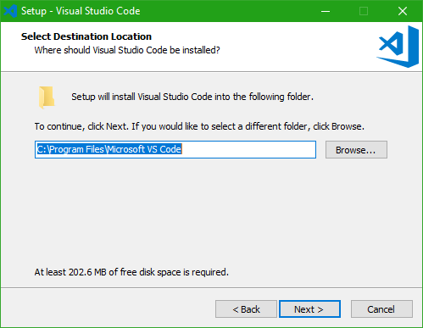

Now hit *Next* to proceed further.Now the page will ask you if you want to create a Start Menu folder entry for Visual Studio Code. According to your preferences, you can now select if you want to or not create a start menu entry for VS Code.

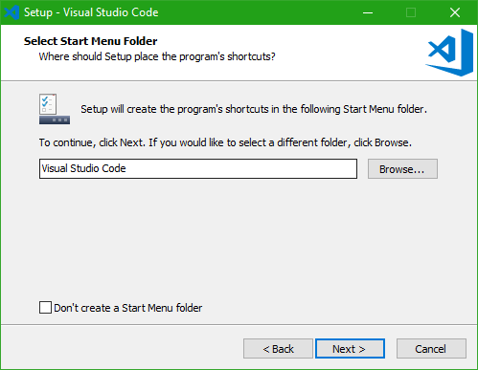

After hitting the *Next* button, the next page will show you some additional options as shown in the screenshot below that you can choose. After you are done, hit *Next.*

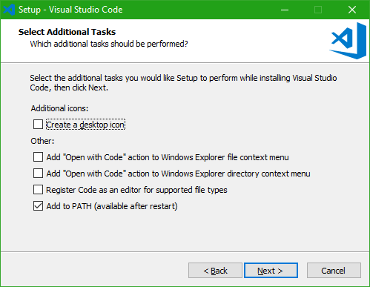

Then it will show you a summary of what preference you have selected to install VS Code, and according to that you can navigate either way and proceed with the installation by hitting the *Install* button.

Now, it will show an installation progress bar. After the installation is done, hit *Finish* to start using Visual Studio Code.

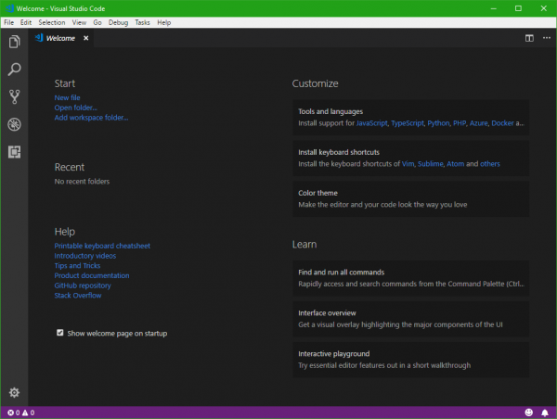

Now, this is the home page of a fresh instance of Visual Studio Code. You can create new projects or use your existing project folders. A wide variety of useful extensions are available for the IDE for you to be productive.

**2. MySQL Download steps**

In the first of a series of MySQL articles, we will discover how easy it is to install the database system on your development PC.

**Why MySQL?** MySQL is undoubtedly the most popular and widely-used open source database:

● it is simple to set up and use

● it is recognised as one of the fastest database engines

● most Linux (and many Windows-based) web hosts offer MySQL

● MySQL is closely integrated with PHP, which makes it an ideal candidate for many web applications.

## **Why Install MySQL Locally?**

Installing MySQL on your development PC allows you to safely create and test a web application without affecting the data or systems on your live website

**Manual Installation**

Manual installation offers several benefits:

● backing up, reinstalling, or moving databases can be achieved in seconds you have more control over how and when MySQL starts

● you can install MySQL anywhere, such as a portable USB drive (useful for client demonstrations).

**Step 1: download MySQL**

Download MySQL from dev.mysql.com/downloads/. Follow *MySQL Community Server*, *Windows* and download the “Without installer” version.

As always, viruses scan the file and check its MD5 checksum using a tool such as fsum.

**Step 2: extract the files**

We will install MySQL to C:mysql, so extract the ZIP to your C: drive and rename the folder from “mysql-x.x.xx-win32” to “mysql”.

MySQL can be installed anywhere on your system. If you want a lightweight installation, you can remove every subfolder except for bin, data, scripts and share.

**Step 3: move the data folder (optional)**

I recommend placing the data folder on another drive or partition to make backups and re-installation easier. For the purposes of this example, we will create a folder called D:MySQLdata and move the contents of C:mysql data into it.

You should now have two folders, D:MySQLdatamysql and D:MySQLdatatest. The original C:mysql data folder can be removed.

**Step 4: create a configuration file**

MySQL provides several configuration methods but, in general, it is easiest to create a my.ini file in the mysql folder. There are hundreds of options to tweak MySQL to your exact requirements, but the simplest my.ini file is:

[mysqld]# installation directory

basedir="C:/mysql/"

# data directory

datadir="D:/MySQLdata/"

**Step 5: test your installation**

The MySQL server is started by running C:mysqlbinmysqld.exe. Open a command box (Start > Run > cmd) and enter the following commands:

cd mysqlbin

mysqld

This will start the MySQL server which listens for requests on localhost port 3306. You can now start the MySQL command line tool and connect to the database. Open another command box and enter:

cd mysqlbin

mysql -u root

This will show a welcome message and the mysql> prompt. Enter “show databases;” to view a list of the predefined databases.

**Step 6: change the root password**The MySQL root user is an all-powerful account that can create and destroy databases. If you are on a shared network, it is advisable to change the default (blank) password. From the mysql> prompt, enter:

UPDATE mysql.user SET password=PASSWORD("my-new-password") WHERE User='root';

FLUSH PRIVILEGES;

You will be prompted for the password the next time you start the MySQL command line.

Enter “exit” at the mysql> prompt to stop the command line client. You should now shut down MySQL with the following command:

mysqladmin.exe -u root shutdown

**Step 7: Install MySQL as a Windows service**

The easiest way to start MySQL is to add it as a Windows service. From a command prompt, enter:

cd mysqlbin

mysqld --install

Open the Control Panel, Administrative Tools, then Services and double-click MySQL. Set the Startup type to “Automatic” to ensure MySQL starts every time you boot your PC.

Alternatively, set the Startup type to “Manual” and launch MySQL whenever you choose using the command “net start mysql”.

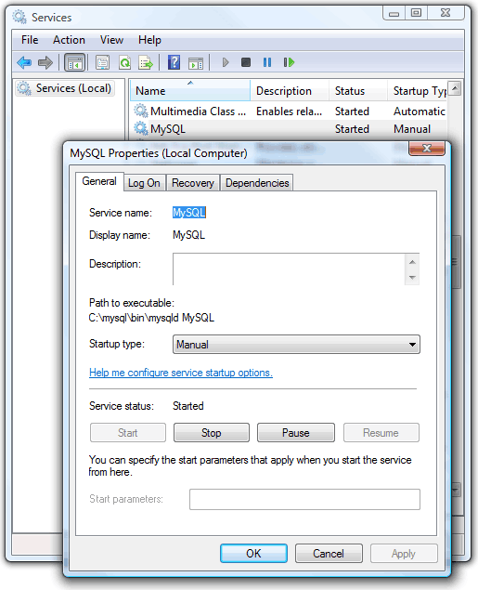

Note that the Windows service can be removed using:

cd mysqlbin

mysqld --remove

**3. Bootstrap Download Steps**

Bootstrap is an open source web framework. It is mainly used for front-end development. It is free of cost. Bootstrap was developed by Bootstrap Core Team. Bootstrap was originally created by Mark Otto and Jacob Thornton. It was initially released in the year 2011. It was written in HTML, CSS, and JavaScript.

**Bootstrap Package**

This package contains the following items:

CSS: It is referred to as a Cascading style sheet that is used to style the HTML elements.

Components: In the Bootstrap package, there are a lot of reusable components for dropdowns, iconography, alerts, navigation etc.

Customize: In the Bootstrap package, the components can be customized, less variable and Jquery plugins to get the style.

Scaffolding: In a bootstrap package, it provides the basic structure with the grid system, link style, and background.

JavaScript: In a bootstrap package, there will be javascript plug-ins.

### **Steps to Install Bootstrap**

Let us discuss the steps required to install Bootstrap.

**Step 1:** Use the below link to get bootstrap downloaded. Click on Download, the bootstrap package will be downloaded in a Zip folder. This folder contains the CSS and JS folder.

<https://getbootstrap.com/docs/4.0/getting-started/download/>

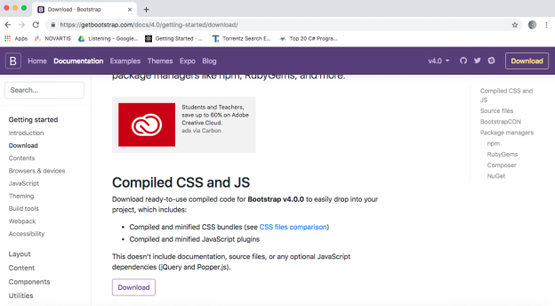The bootstrap package which is downloaded is ready to use compiled code and that can be easily integrated into the project. It consists of compiled and minified CSS bundles and Javascript Plugins.

**Step 2**: Source file: Bootstrap can be compiled with its own asset pipeline with help of javascript, sass and documentation files.

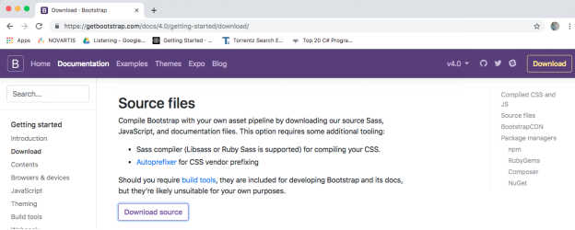

Click on Download Source to get the files downloaded. It contains js, CSS and other files.

**Step 3:** Package Managers: Bootstrap can be installed in [Node.js powered](https://www.educba.com/uses-of-node-dot-js/) files or applications.

$ npm install bootstrap

**Step 4**: For Node.js applications, bootstrap can be installed with help of the yarn package as well.

$ yarn add bootstrap

**Step 5:** If the user wants to install bootstrap for ruby gems applications

● Using bundler:

● gem ‘bootstrap’, ‘~> 4.0.0’

● Without bundler:

● $ gem install bootstrap –v 4.0.0

**Step 6**: The composer can be used to install and manage the bootstraps sass and javascript

$ Composer require twbs/bootstrap: 4.0.0

**Step 7**: Using NuGet, you can install and manage bootstraps CSS and sass and javascript for.Net applications.

● Install-Package bootstrap

● Install-Package bootstrap.sass

**Step 8**: Jquery is also being used with bootstrap files or installation folders. Jquery needs to be downloaded and placed in the Jquery file in the Bootstrap root folder for experiencing the better user interface and most importantly Jquery enhances the features of Bootstrap that provides the look more attractive and responsive.

**Step 9**: After executing the above steps, the developer can write the HTML code to link all the files for the HTML page and can open the HTML file to check the response.

### **Supported Browsers** The bootstrap mainly supports the latest and stable release of all the browser and platform. Mobile devices browsers have supported Android and IOS platforms. The desktop browsers for different platforms like Mac and Windows are also supported by bootstrap.

### **Bootstrap File structure**

● Bootstrap has been precompiled, the compiled version of bootstrap being is downloaded and extract the Zip file and the following file structure you will see:

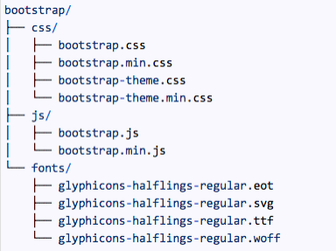

The above figure includes the fonts folder files as well if the developer requires extra fonts to make the user interface according to requirements can include files that are available in the source package of bootstrap. The bootstrap source code will have a more detailed file structure.

### **Bootstrap 4**

There are significant changes that are done in Bootstrap 4 like rewriting the code majorly, CSS flexible size support, navigation customization options have been added, response spacing and sizing utilities are added, the global font size is increased from 14px to 16px, number of utility classes are added, styling button, drop down menus, media objects and image classes are added. It also supports the latest version of browsers.

The main feature of Bootstrap is to simplify the development of web pages. The primary reason to use bootstrap is the choice of color, size, font, and layout to project. It provides basic style definitions to HTML elements. The Jquery plugins and Javascript components provide some additional elements that can be used for user interface like dialog boxes, and tooltips etc. The bootstrap components also consist of elements of HTML, CSS declarations and Javascript code as well. It also has a feature of extending the existing interface elements.

The other main component of bootstrap is its layout components. The basic layout component is called a container in which every element of the page is placed in it. The container is placed on the web page then other layout components like CSS layout can be defined through rows and columns. It depends on the developer to choose which container fixed width or fluid width container for designing the web page. The former uses the four predefined widths but later uses the fills depending on the size of the screen on which the web page is getting viewed.

### **Usage of bootstrap**

Bootstrap is very easy to use and with the help of bootstrap, developers used to develop responsive web sites. Bootstrap is also used as it supports many browsers like Google Chrome, Mozilla Firefox, Internet Explorer, Safari, Opera etc. Bootstrap is easy to get started and to create a responsive grid system. It has bundled javascript plug-ins and there is a list of companies to use. It has good documentation to start and able to work quickly. Bootstrap has shown responsive design and mobile first approach. It is open source and free of cost. It saves a lot of effort and time. It is customizable. The important usage of bootstrap is a responsive web design, which helps in adjusting the website according to screen size for all the devices like laptop, desktop, mobile phone, and tablet.

**1. Information about the Full Stack Development**

**1.1 Web Development:** Web development is the work involved in developing a website for the Internet or an intranet. Web development can range from developing a simple single static page of plain text to complex web-based internet applications, electronic businesses, and social network services

**1.1.1 Web Site:** A website (also written as a web site) is a collection of web pages and related content that is identified by a common domain name and published on at least one web server. Notable examples are wikipedia.org, google.com, and amazon.com. All publicly accessible websites collectively constitute the World Wide Web. There are also private websites that can only be accessed on a private network, such as a company's internal website for its employees. Websites are typically dedicated to a particular topic or purpose, such as news, education, commerce, entertainment, or social networking. Hyperlinking between web pages guides the navigation of the site, which often starts with a home page. Users can access websites on a range of devices, including desktops, laptops, tablets, and smartphones. The software application used on these devices is called a web browser.

**1.1.2 Web Page**

A web page (or webpage) is a specific collection of information provided by a website and displayed to a [user](https://en.wikipedia.org/wiki/User_(computing)) in a web browser. A website typically consists of many web pages linked together in a coherent fashion. The name "web page" is a metaphor of paper pages bound together into a book.

**1.2 Steps to Create a Web site**

**1.2.1 UI Development**

● Every Web Developer must have a basic understanding of HTML, CSS, and JavaScript.

● Responsive Web Design is used in all types of modern web development.

● ECMAScript 5 (JavaScript 5) is supported in all modern browsers. Take a good look at it, especially the new array functions.

● When you feel comfortable with HTML and CSS, it is time to dig deeper.

● You should learn how to use Maps, Fonts and Icons in HTML.

● On the JavaScript side, you should learn how to access the HTML DOM.

● You should also learn how to use AJAX and JSON for making server requests.

**1.2.2 Scripting**

JavaScript

On the JavaScript side you should learn at least one modern framework:

● React.js

● Angular.js

● Vue.js

● W3.JS

Maybe the popularity of jQuery has passed the top, but it is still the most used JavaScript framework.

**1.2.3 Database**

A database is an organized collection of data, generally stored and accessed electronically from a computer system. Where databases are more complex they are often developed using formal design and modeling techniques. “musicstore.sql”

**2. Software Requirements:**

**2.1 Hardware Requirements**

Processor : Any Update Processor

Ram : Min 1 GB

Hard Disk : Min 100 GB

**2.2 Software Requirements**

Operating System : Windows family

Technology : Java (1.7/1.8)

Web Technologies : Html, Html-5, JavaScript, CSS.

Web Server : MySQL

Server side Lang : J2EE

Database : My SQL5.5

UML : Star UML

DFD : DFD Drawer

**3. PROJECT NAME**

**3.1 Project Name: “Online Music System”**

**Give information about the project** The main aim of creating this Online Music System Java based web application it’s a collection of audio songs of different languages in one place where users can get based on the year also play and lesion the songs in our website at free of cost only is to provide a user friendly tool for music websites. This is one type of online music Player. Most of the websites nowadays use Music products online but downloading music files free of cost makes problems with piracy so this is the best place to stop music piracy over the internet. Here the customer should login through the Music store website and play & Lesion selected music files like songs. Then selected music files can be downloaded directly to the local system of the customer. The main advantage is it is user friendly, provides us 24 hours customer service, and decreases the manual efforts and Time.

**3.3 Technical Details:**

# **Software Configuration**

Operating System : Windows Family

Application Server : MySQL Server

Front End : HTML, Java, Jsp

Scripts : JavaScript.

Server side Script : Java Server Pages.

Database : Mysql 5.0

Database Connectivity : JDBC.

**4. MODULES:**

**Admin**

Admin will collect all the Data for Our Online Music System like Songs Names, Film Name, Language, Play Link, year of The Song & Store in Our Data Base

**Existing User**

Existing User will login in to our website by giving his username & password in to our Online Music System& access all the songs as per his/her Requirement based on the language or year...

**New User**

If the new person who is coming to our Online Music System has to create an account in our website by giving his/her basic information like name first name email id phone no address which will be confident in our database have to keep a user name & password for next login ..

**5. OUTPUTS**

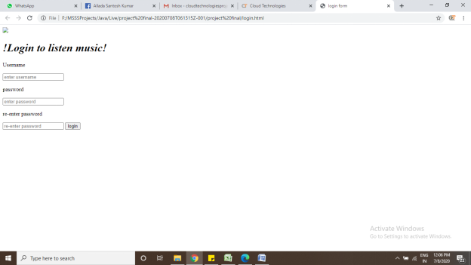

* **Login.html**

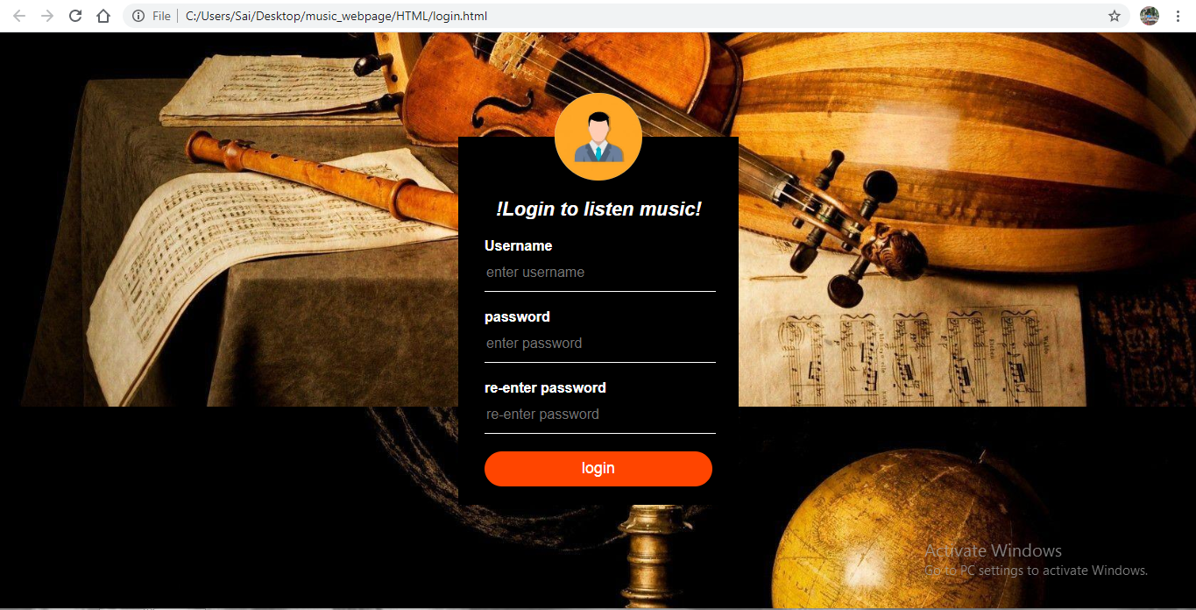

**After entering all details correctly as per requirement: Username:** username should be of only characters

**Password:**the length of the password is at-least 8

**re-enter password:**it should be matched with the original password.

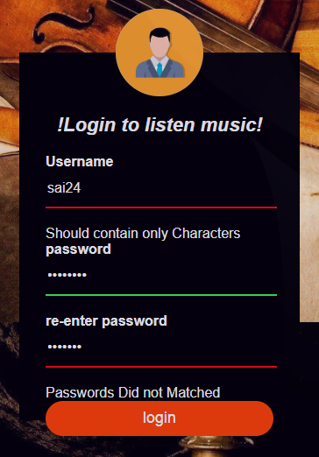

If we give, wrong input **RED ,**light is highlighted.

If we give correct input ,**GREEN** light is highlighted as below

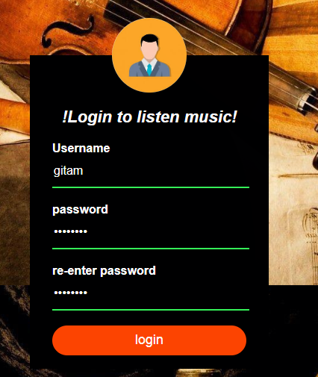

On giving correct input click on the login button.

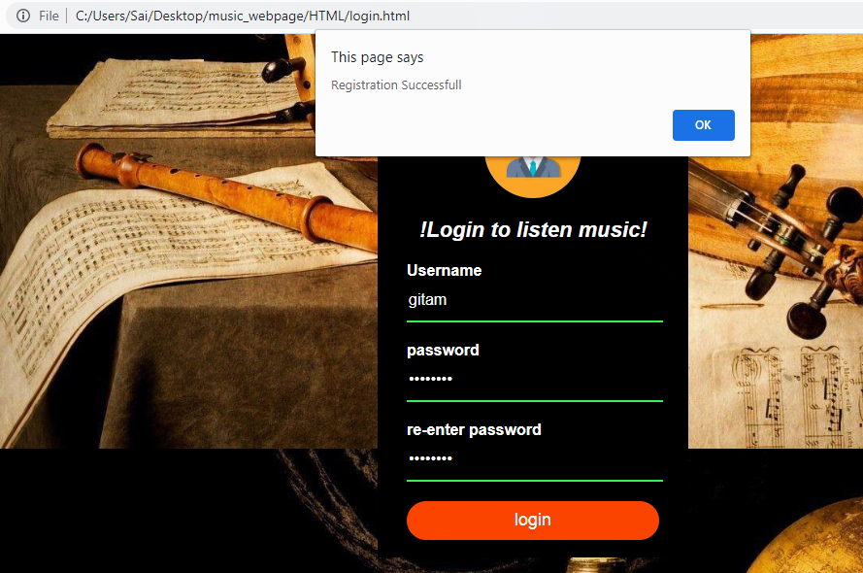

It says the registration page is successful!!

Click on it, IT WILL **REDIRECT TO music.html** page.

**WIREFRAMES:-**

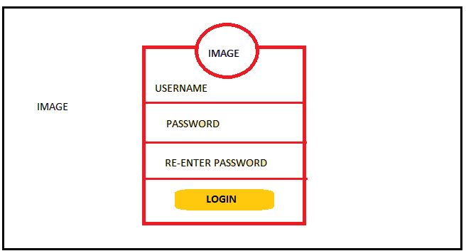

**7 CONCLUSION:**

Our Online Music System Java predicated web application it’s an accumulation of audio musical compositions of different languages in one place where users can get predicated on the year with play and Listen the musical compositions on our website at free of cost only is to provide cordial implementation for music websites.